COMPLETE LOOK, SAY, ACT, COVER, WRITE, CHECK with ALL SPELLINGS. |  |  |  | Name:__ Date 1/3/21  Vocabulary in Action – Year One  If you complete this booklet and would like to do more, here are a couple of extension activities you can do:  Rainbow write  First, write each word in pencil, then trace over each word three times, each time you trace you must use a different colour crayon and say the sounds.  Air Write!  Write your spelling words in the air using your finger. Ask someone to read your words as you write them OR have them air write and you read them.  The /yoo/ and /oo/ sounds spelt with split digraph ‘u-e’  June rule  rude use  cube tune  cube huge  cute flute  Can you think of any more words with the  /u-e/ split digraph?  Write them below.
June
rule
rude
use
tube
tune
cube
huge
cute
flute

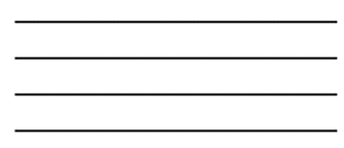
- Choose three words from the spelling list.
Then draw a picture for each word.

2. Now choose three different words from the spelling list and put them into a sentence.

